Java-based configuration in Spring allows you to manage the Spring container and its beans using pure Java classes instead of traditional XML files. This approach, introduced in Spring 3.0, offers type safety at compile time and better IDE support for navigation and refactoring.

Two primary annotations drive Java-based configuration:
- @Configuration: Marks a class as a source of bean definitions.
- @Bean: Placed on methods within a @Configuration class to indicate that the method returns an object that Spring should manage as a bean.

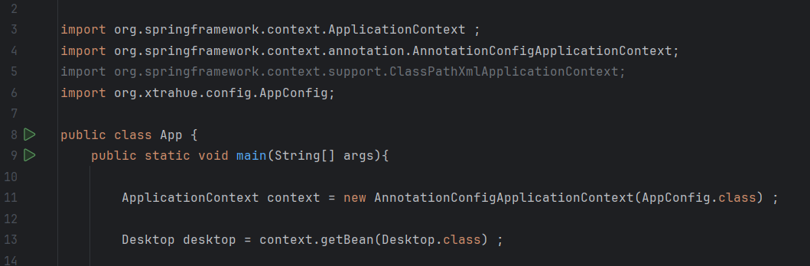
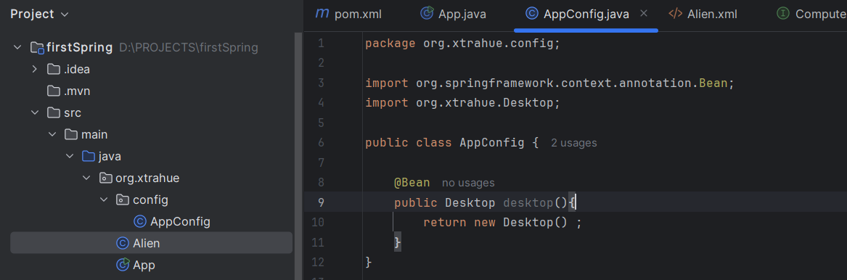

177_Bean Name:
In case of Desktop the default bean name is: desktop (As “desktop” is the method name in the config file).
You can give another names also inside the @Bean. E.g.: @Bean(“Desk1”)
Or, you can keep multiple names: E.g.: @Bean({“Desk1”, “Comp1”, “Mach1”})
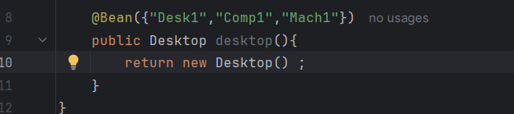
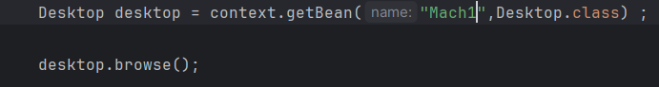

178. Scope:
@Scope(“prototype”): works the same way as xml based configuration.

